
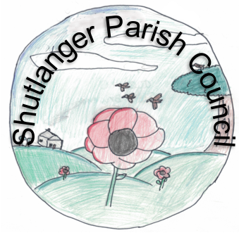

THE ANNUAL VILLAGE MEETING

HELD ON THURSDAY 9th MAY 2019
AT 7.30 P.M.
IN THE VILLAGE HALL.

Meeting Notes

- APOLOGIES were received from Councillor Sandra Barnes SNC

- The MINUTES of the 2018 meeting were agreed and signed by the Chairman

- No new matters arose from the MATTERS ARISING from those Minutes

- The CHAIRMAN’S REPORT was presented by the Clerk which showed the achievements of the Parish Council in the last financial year.

- The ACCOUNTS OF THE PARISH COUNCIL were presented.

- The report from COUNTY AND DISTRICT COUNCILLORS was not made but will be made at the next Parish Council meeting on 9 July 2019.

- The report from VILLAGE HALL REPRESENTATIVE was presented by the Clerk.

13. There were no new MATTERS PARISHONERS WISH TO RAISE

14. DATE OF NEXT MEETING – Thursday May 14th, 2020

Julia Lindsay

JULIA LINDSAY
Chair of the Parish Council

